**Mini Project Report**

**On**

**Student Report Card Management**



**Submitted To: Graphic Era University Submitted By: Harsh Yadav**

**University Roll Number: 2014397**

**Semester – VII**

For fulfillment of the Award of the Degree

Bachelor of Technology, III Semester(Back)

Batch – 2019-2023

In

Computer Engineering

## **Abstract**

The present project is aimed to be create a C++ program that can store, retrieve, display, insert, delete and modify a student's marks in their subjects. The program is completely menu driven without any graphical interface. The data is stored in a binary file for future reference.

**Keywords**

Student Report card management, C++, OOPs

**INTRODUCTION**

The project Student Report Card Management is aimed to efficiently

store and retrieve student examination reports. This project in C++ is a simple console application built without any graphical Interface. In this project, users can perform typical report card related functions like adding a new student record and displaying, modifying, editing and deleting it. File handling has been effectively used to perform all these.

This project will teach you how to use file handling in C++,add, read, display, search, modify and delete record from file. The key features and the functions used for the Student Report Card Management are:

**1. Create student report card record:** This feature

creates a new student record containing his marks. Void

write_student(); function writes a record in a binary file. For

this the information to be provided are the name and roll no.

of the student, and the marks obtained by him/her in 5 subjects

– OOPs, Data Structures, Analog and Digital Electronics,

Computer Organization and Architecture and Computer

Oriented Statistical Methods.

**2. Read all students report card record:** The void

display_all(); function in this student report card management

system project in C++ has been used for this feature. It shows

the progress report of all the students added in file. This

feature displays the roll no. and name of all the students, the

marks obtained by them in 5 subjects – OOPs, Data Structures,

Analog and Digital Electronics, Computer Organization and

Architecture and Computer Oriented Statistical Methods

along with the percentage and grade of each student.

**3. Read specific student’s report card record:** This feature is same as the one explained above, except it shows the progress report and relevant data related to a particular

student. void display_sp(int) is used for this purpose.

**4. Display all students’ grade report:** This feature enlists

all the students’ record saved in file. The grade report is

displayed in a tabular form with roll no. and name of the

students, marks achieved in the five subjects, and the grade

and percentage obtained by them. void class_result(); is thus

used.

5. Modify student’s report card record: void

**5. Modify student’s report card record:** void modify_student(int); function is used to edit the report card

record of a particular student. For this, the name and roll no.

of the student is sought. Upon successful modification, the

program displays the message “Record Updated”. If no record

of student is found in file, it displays the message “Record not

found”.

**6. Delete student record:** void delete_student(int);

function deletes the report card record of a particular student;

it first of all asks for the name and roll no. of the student whose

record is to be deleted.

**HEADER FILES USED**

Header Files Used:

Student report card system is a very simple project that

runs with just five header files. Here, are the header files

required for this project:

**1. #include<iostream>**

It is used as a stream of Input

and Output using cin and cout.

**2. #include<fstream.h>**

It is used to control the data to read from a file as an input

and data to write into the file as an output.

**3. #include<iomanip>**

It is used to access set() and setprecision() function to

limit the decimal places in variables.

**4. #include <stdlib.h>**

The stdlib.h header defines four variable types, several

macros, and various functions for performing general

functions.

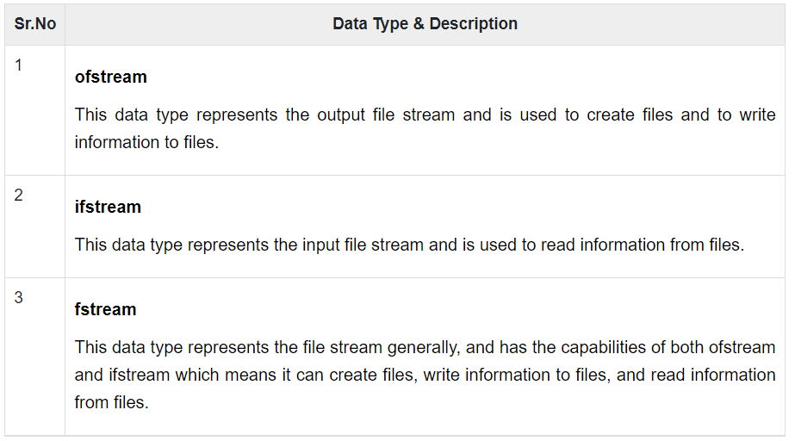

**DEMO AND DISCUSSION**

When the program is run, the user is welcomed with an

introduction screen. The user is prompted to press the enter

key. The enter key will then navigate the user to the Main

Menu. The Main menu is the heart of our program and

contains all the main operations.

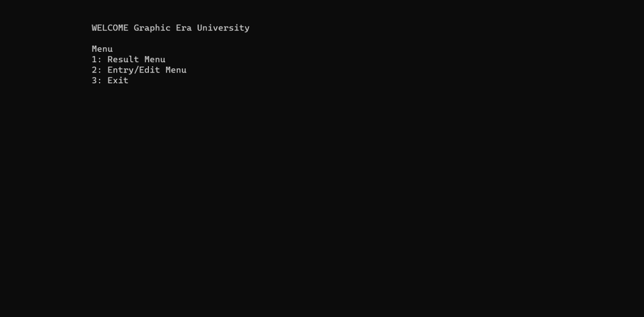

The intro menu which appears immediately pops up when you run and build the code.

The Menu screen will have the options to

**1. Create a student’s record:** This will add the details of a new student into the binary file.

**2. Display all the student records:** Can retrieve all the records present in the file.

**3. Display one student’s record:** We can use this to retrieve a single student data.

**4. Edit a student’s record:** Incase of any mistakes while adding the student data, we can also edit the data using this edit option.

**5. Delete a student’s record:** When we no longer require a student record, we can simply delete the record using their roll

number.

**6. Go back to main menu:** This will navigate the user to Main menu.

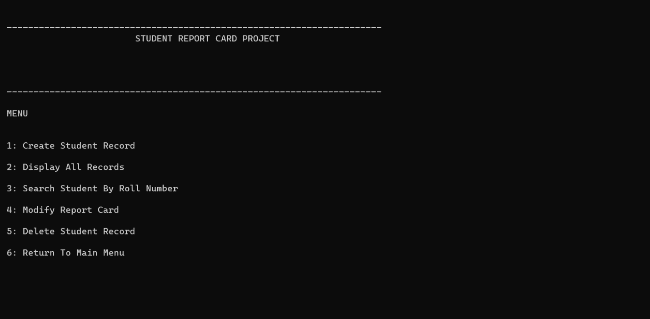

Menu in order to Add/ Modify/ Delete student record.

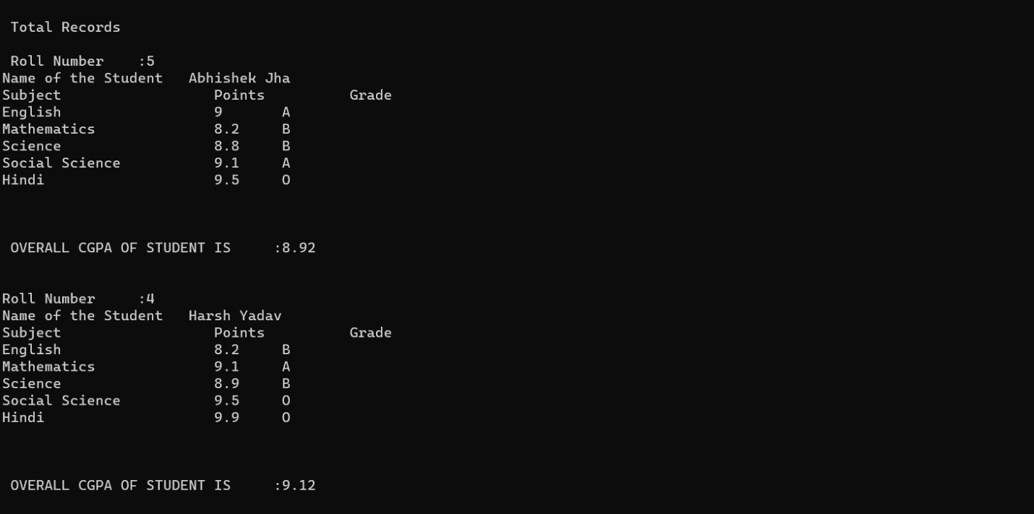

**CONCLUSION**

This report contains the Student Report Card Management

project made using CPP by Harsh Yadav, CS-CE(VII Semester) submitting for our Object-Oriented Programming using C++ mini project for the mini project back(III Semester) of batch 2019-2023.